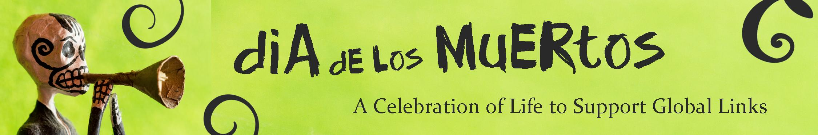
Contact: Angela Garcia, Deputy Director, 412-735-6212 (cell)

The Party Just Keeps Getting Bigger!
Attack Theatre, Astrologers, Tarot, Haunted Pinball Join the Fun

Dia De Los Muertos (Day of the Dead)
A Celebration of Life to Support Global Links

presented by UPMC / UPMC Health Plan

Saturday, October 24

(PITTSBURGH) July 24, 2015 -- Join Pittsburgh-based medical relief and development organization, Global Links for an evening celebrating the traditions of the Mexican holiday “Dia De Los Muertos (Day of the Dead)”, Saturday, October 24, from 6:30 – 11:00 p.m.
Back by popular demand, this is Global Links’ second annual event marking Dia De Los Muertos, which in Mexico is a day of celebration and remembrance of departed loved ones. Global Links is honoring these joyous traditions with an evening of food, cocktails, art and entertainment at its warehouse headquarters.
Guests can choose between the VIP Experience with a private dinner prepared by special guest and Big Burrito Head Chef Bill Fuller, signature cocktails, and a live performance by the Mariachi Fiesta Band; or General Admission featuring delicious Latin American street food, beer and wine; art; a performance by Attack Theatre; and dancing well into the night with DJ Wayne Smith. And new this year: haunted pinball machines from the Pennsylvania Coin Operated Hall of Fame & Museum.
Guests are encouraged to attend in their most extravagant costume or dress in the Dia De Los Muertos colors of orange, yellow, purple, red or pink. They can complete their look during the event with traditional Day of the Dead face painting and capture it forever in the on-site Selfie Studios booth. Funds raised will support the life-saving work of Global Links. Tickets on sale at www.globallinks.org; call 412.361.3424, x203 for more information.

-more-
All the Deadly Details:
Dia De Los Muertos: A Celebration of Life Supporting Global Links
Saturday, October 24
6:30 – 11:00 p.m.
Global Links Headquarters
700 Trumbull Drive
Pittsburgh, PA 15205
VIP Experience (6:30 p.m. – 11 p.m.): $125
- Private dinner by Kaya and food demonstration by special guest, Big Burrito Head Chef, Bill Fuller
- Beer, wine, and a signature DdlM cocktail
- Early access to face painters, astrologers and tarot card readers
- Live musical performance by the Mariachi Fiesta band
- Music and dancing into the evening with access to all the General Admission fun
General Admission (8 p.m. – 11 p.m.): $55
- Delicious Latin-inspired street food from: Edgar's Tacos, La Palapa, El Burro, Gabrielle's Empanadas, Mad Mex, Cinco de Mayo Salsas, Popsburgh and more
- Beer and wine bar
- Dia de los Muertos face painting
- Selfie Studios photo booth
- Astrological readings with Judi Vitale and tarot card readings with Angel
- Fortune telling and haunted pinball machines from the Pennsylvania Coin Operated Hall of Fame & Museum
- Dancing with an all-vinyl soundtrack from DJ Wayne Smith and a special Attack Theatre performance

About Global Links
Global Links is a medical relief and development organization dedicated to supporting health improvement initiatives in resource-poor communities, primarily in the Western Hemisphere. Global Links collaborates with US healthcare institutions and the community to recover hundreds of tons of high-quality surplus medical materials every year that would otherwise be sent to landfills.
These materials are shared with public health facilities around the world and non-profit organizations in Western Pennsylvania that are providing care for their community’s most vulnerable people. For more information, visit www.globallinks.org.

###

